These partial differential equations (PDE) can be used to model, for example, the propagation of tsunamis. The shallow-water equations in non-conservative form are given by

where u(x, y) and v(x, y) are the x- and y-components of velocity, h(x, y) is the surface height, and g is the acceleration due to gravity. For simplicity, we have neglected friction, Coriolis and viscous forces.

The spatial derivatives are solved with 6th order central difference as:

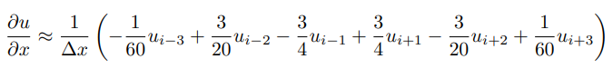

The domain is square with dx=dy=1

The time integration is made with the 4th order Runge Kutta explicit scheme as:

The code test 4 cases for the propagation of waves:

1. Plane waves propagation in x

1. Plane waves propagation in y

1. Single droplet

1. Double droplet

